**Developer Guide**

* Introduction
* Setting Up
* Design
* Implementation
* Testing
* Dev Ops
* Appendix A: User Stories
* Appendix B: Use Cases
* Appendix C: Non Functional Requirements
* Appendix D: Glossary
* Appendix E: Product Survey

## Introduction

TasKitty is an easy-to-use task manager designed specially for the average computer or laptop user who wants to keep track of their busy schedules. It is a Java desktop application that is perfect for keyboard lovers, as it implements a command-line interface in its GUI.

This guide describes the design and implementation of TasKitty. It will help you understand how TasKitty works and how you can further contribute to its development. We have organised this guide into the 4 major components that make up the core functionality of TasKitty, so that you can have an overview of how these essential components are linked before reading further into the parts that make up each component respectively.

## Setting up

### Prerequisites

1. **JDK 1.8.0_60** or later



Having any java 8 Version is not enough

This app will not work with earlier versions of Java 8

1. **Eclipse** IDE
2. **e(fx)clipse** plugin for Eclipse (Do the steps 2 onwards given in [this page](http://www.eclipse.org/efxclipse/install.html#for-the-ambitious))
3. **Buildship Gradle Integration** plugin from the Eclipse Marketplace

### Importing the Project into Eclipse

1. Fork this repo, and clone the fork to your computer
2. Open Eclipse (Ensure you have installed **e(fx)clipse** and **buildship plugins** as give in prerequites above)
3. Click File > Import
4. Click Gradle > Gradle Project > Next > Next
5. Click Browse, then locate the project's directory
6. Click Finish

If you are asked whether to ‘keep’ or ‘overwrite’ config files, choose to ‘keep’

Depending on your connection speed and server load, it can take up to 30 minutes for the set up to finish (This is because Gradle downloads library files from servers during the project set up process)

You can discard any changes that Eclipse may have auto-changed in any settings files during the import process

## Design

### Architecture

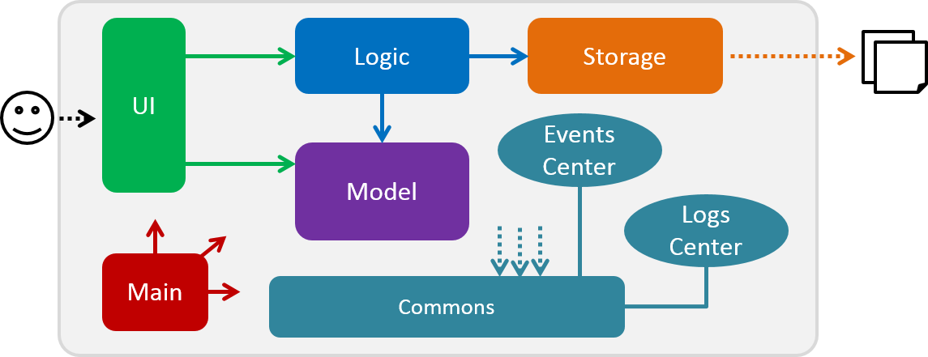

Figure 1: High Level Architecture Diagram

Figure 1 above shows the High Level Architecture Diagram. It explains the high-level design of TasKitty. Given below is a quick overview of each component.

Main has only one class called [MainApp](../src/main/java/seedu/taskitty/MainApp.java). It is responsible for

* initializing the components in the correct sequence, and connecting them with each other at app launch.
* shutting down the components and invoking the cleanup method where necessary at shut down.

**Commons** represents a collection of classes used by multiple other components. Two of those classes play important roles at the architecture level:

* EventsCentre : This class (written using [Google's Event Bus library](https://github.com/google/guava/wiki/EventBusExplained)) is used by components to communicate with other components using events (i.e. a form of *Event Driven*design).
* LogsCenter : This class is used by many classes to write log messages to the App's log file.

The rest of the App consists of four components.

* **UI** : Handles user interactions with the application.
* **Logic** : Parses and executes commands.
* **Model** : Holds the data of the App in-memory.
* **Storage** : Reads data from, and writes data to, the hard disk.

Each of the four components

* defines its *API* in an interfacewith the same name as the component.
* exposes its functionality using a {Component Name}Manager class.

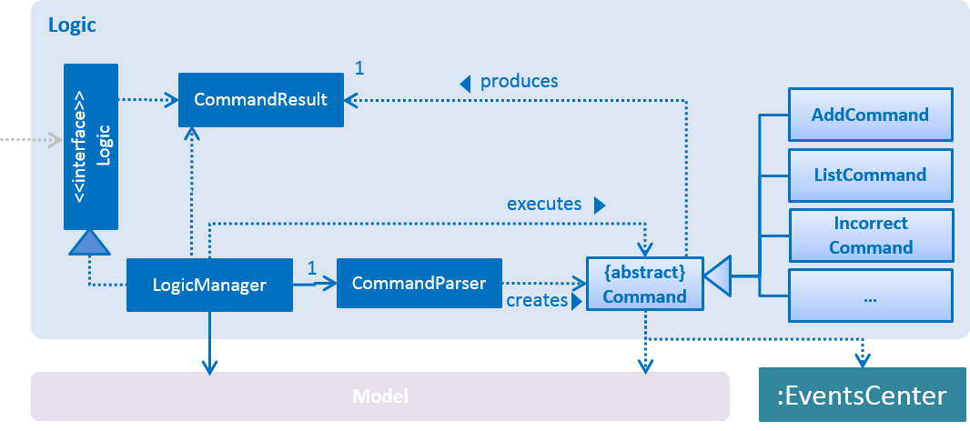

Figure 2: Logic Class Diagram

For example, Figure 2 above shows the Logic component that defines its API in the Logic.java interface and exposes its functionality using the LogicManager.java class.

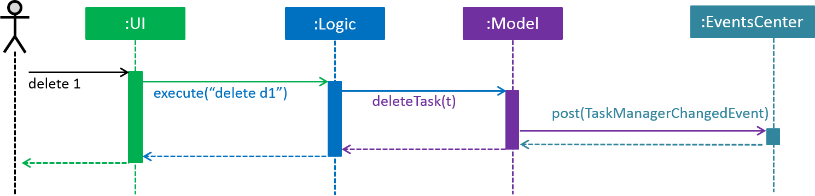

Figure 3: Sequence Diagram for Delete Task

Figure 3 above, the *Sequence Diagram*, shows how the components interact for the scenario where the user issues the command delete d1.

Note how the Model simply raises a TaskManagerChangedEvent when the TaskManager data are changed, instead of asking the Storage to save the updates to the hard disk.

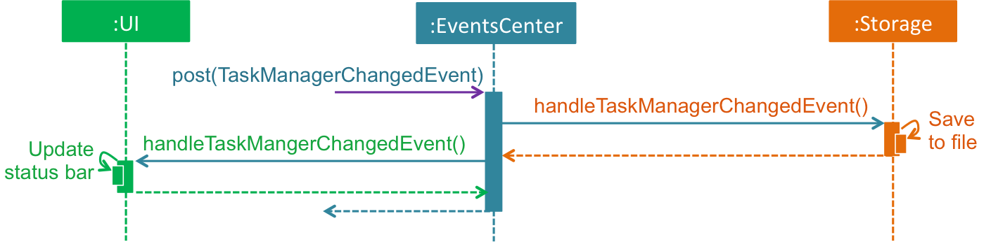

Figure 4: Sequence Diagram for Delete Task Event Handling

Figure 4 above shows how the EventsCenter reacts to that event, which eventually results in the updates being saved to the hard disk and the status bar of the UI being updated to reflect the 'Last Updated' time.

Note how the event is propagated through the EventsCenter to the Storage and UI without Model having to be coupled to either of them. This is an example of how this Event Driven approach helps us reduce direct coupling between components.

The sections below give more details of each component.

### UI Component

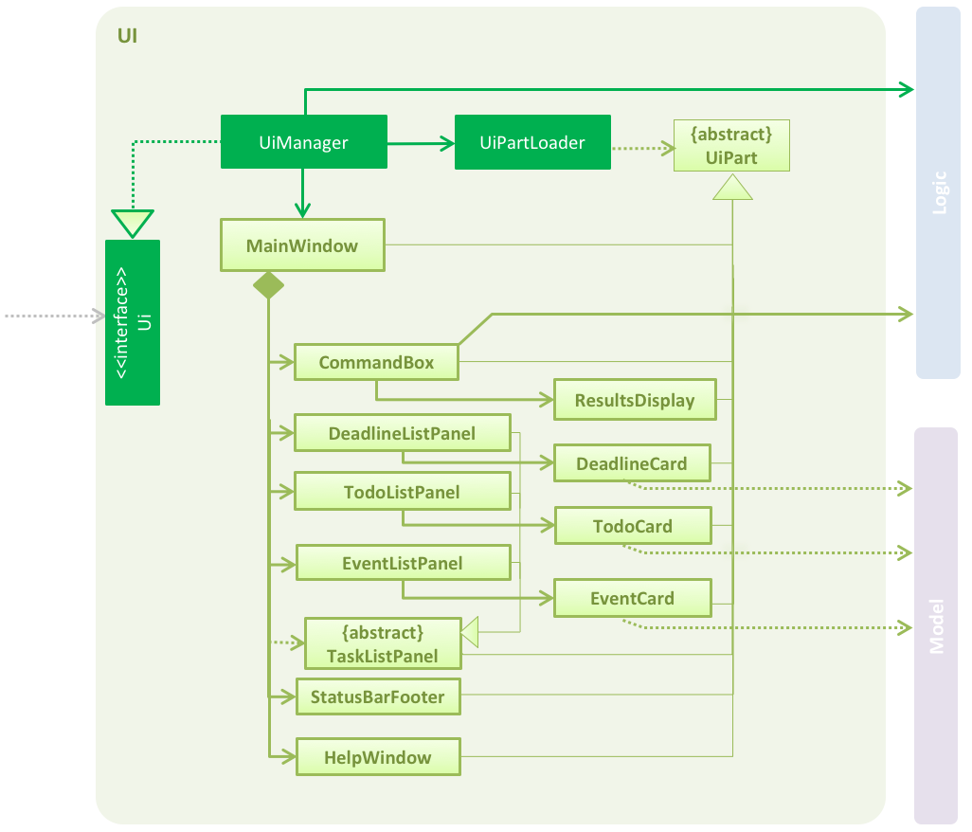

Figure 5: UI Class Diagram

**API** : [Ui.java](../src/main/java/seedu/taskitty/ui/Ui.java)  
Figure 5 shows the UI class diagram.  
The UI consists of a MainWindow that is made up of parts e.g.CommandBox, ResultDisplay, TodoListPanel,StatusBarFooter, EventsListPanel etc. All these, including the MainWindow, inherit from the abstract UiPartclass and they can be loaded using the UiPartLoader.

The MainWindow also depends on the abstract class TaskListPanel to load the 3 inherited classes: TodoListPanel, DeadlineListPanel, and EventListPanel.

The UI component uses JavaFx UI framework. The layouts of these UI parts are defined in matching .fxml files that are in the src/main/resources/view folder.

For example, the layout of the [MainWindow](../src/main/java/seedu/taskitty/ui/MainWindow.java) is specified in [MainWindow.fxml](../src/main/resources/view/MainWindow.fxml).

The UI component:

* executes user commands using the Logiccomponent.
* binds itself to some data in the Model so that the UI can auto-update when data in the Model change.
* responds to events raised from various parts of the App and updates the UI accordingly.

### Logic Component



Figure 6: Logic Class Diagram

**API** : [Logic.java](../src/main/java/seedu/taskitty/logic/Logic.java)  
Figure 6 shows the Logic class diagram.  
Logic uses the CommandParser class to parse the user command.  
This results in a Command object which is executed by the LogicManager.

The command execution can affect the Model (e.g. adding a task) or Storage (e.g. set new save file path) and/or raise events.

The result of the command execution is encapsulated as a CommandResult object which is passed back to the Ui.

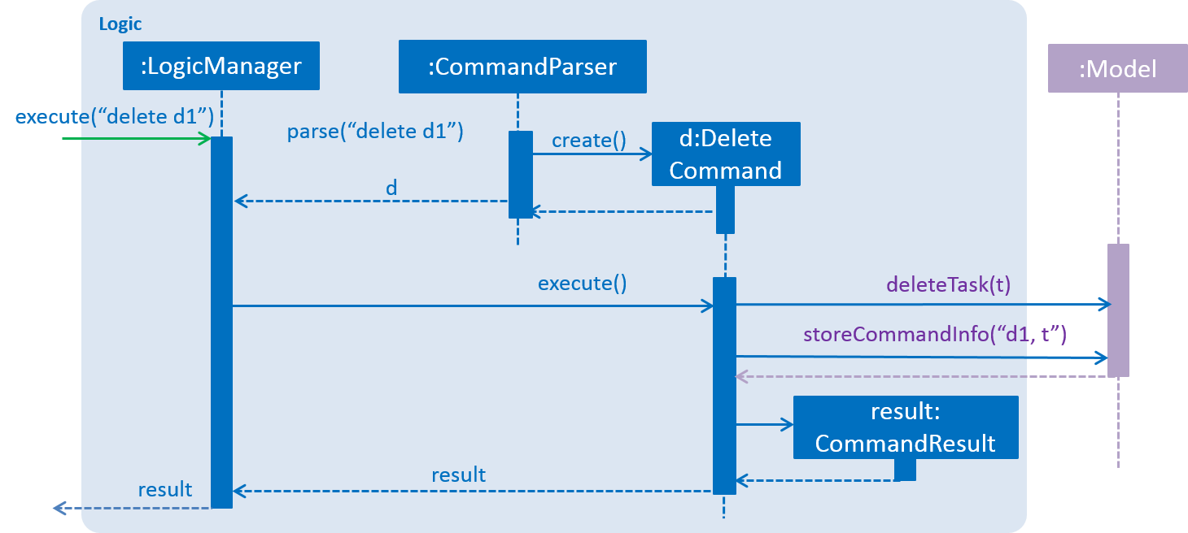

Figure 7: Delete Task Sequence Diagram for Logic DeleteCommand

Figure 7 above shows the Sequence Diagram for interactions within the Logic component and with the Model for the execute("delete d1") API call.

Note that commands that affects the TaskManager inside of Model will store the command information after successful execution (before execution for ClearCommand) , while other commands does not need to store any command information.

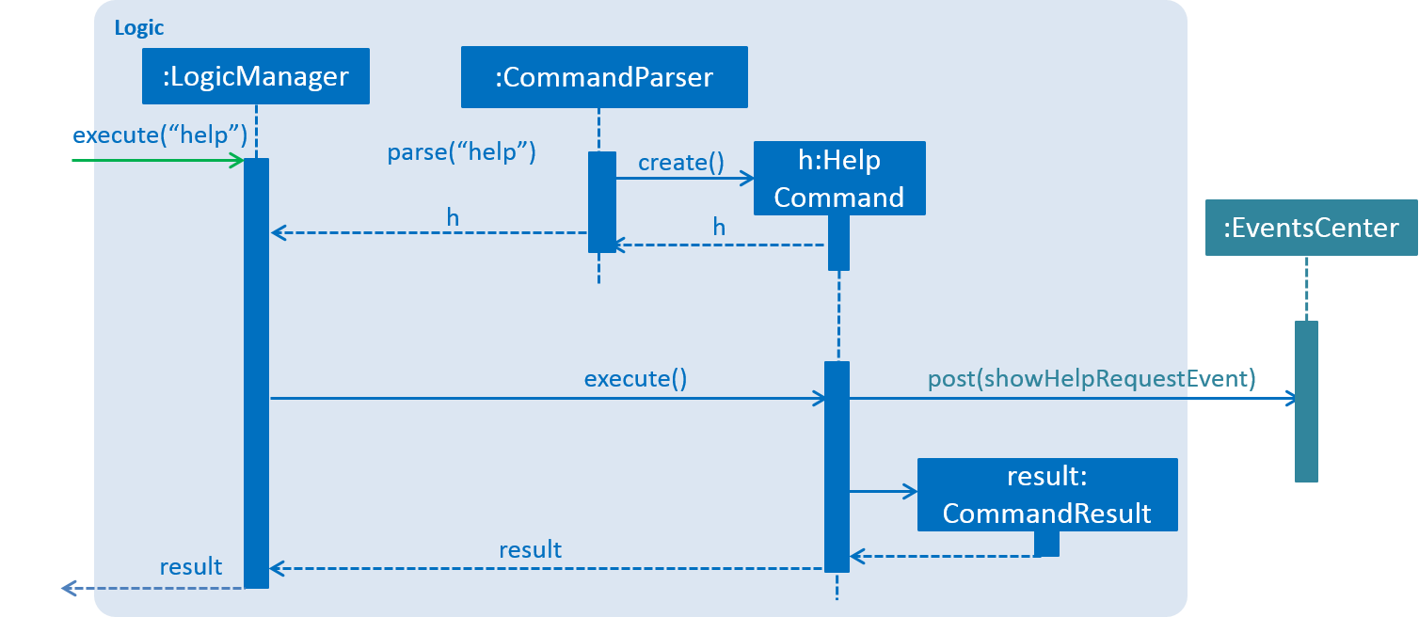

Figure 8: Delete Task Sequence Diagram for Logic HelpCommand

Figure 8 above shows the Sequence Diagram for interactions within the Logic component, where the Command directly posts an Event to the EventsCenter for the execute("help") API call.

### Model Component

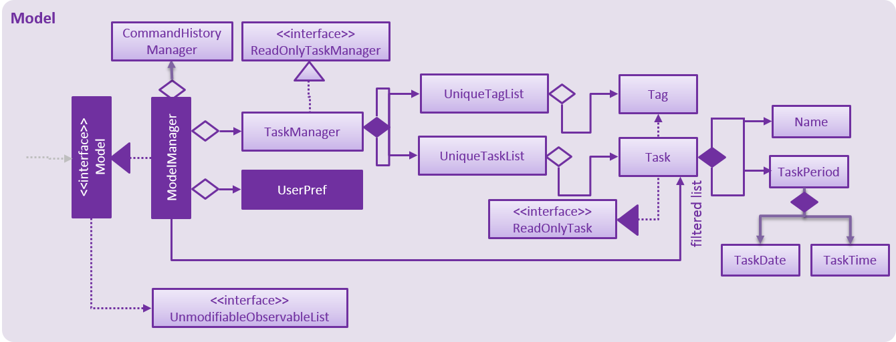

Figure 8: Model Class Diagram

**API** : [Model.java](../src/main/java/seedu/taskitty/model/Model.java)  
Figure 8 above shows the Model class diagram.  
The Modelcomponent:

* stores a UserPref object that represents the user's preferences.
* stores the Task Manager data.
* stores previous executed command information necessary for undo/redo function in a CommandHistoryManager class.
* exposes a UnmodifiableObservableList<ReadOnlyTask>that can be 'observed' e.g. the UI can be bound to this list so that the UI automatically updates when the data in the list change.
* does not depend on any of the other three components.

### Storage Component

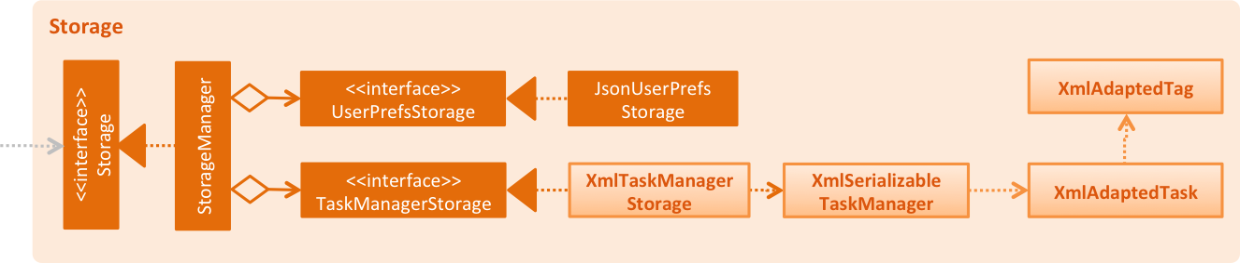

Figure 9: Storage Class Diagram

**API** : [Storage.java](../src/main/java/seedu/taskitty/storage/Storage.java)  
Figure 9 above shows the Storage class diagram.  
The Storage component:

* saves UserPrefs objects in json format and reads it back.
* saves the Task Manager data in xml format and reads it back.

### Common Classes

Classes used by multiple components are in seedu.taskitty.commons.

## Implementation

### Configuration

Certain properties of the application can be controlled (e.g App name, logging level) through the configuration file (default: config.json).

### Logging

We are using java.util.logging package for logging. The LogsCenter class is used to manage the logging levels and logging destinations.

* The logging level can be controlled using the logLevelsetting in the configuration file (See Configuration).
* The Logger for a class can be obtained using LogsCenter.getLogger(Class) which will log messages according to the specified logging level.
* Currently log messages are output through: Console and to a .log file.

**Logging Levels**

* SEVERE : Critical problem detected which may possibly cause the termination of the application
* WARNING : Can continue, but with caution
* INFO : Information showing the noteworthy actions by the App
* FINE : Details that are not usually noteworthy but may be useful in debugging e.g. print the actual list instead of just its size

## Testing

Tests can be found in the ./src/test/java folder.

**In Eclipse**:

If you are not using a recent Eclipse version (i.e. *Neon* or later), enable assertions in JUnit tests as described [here](http://stackoverflow.com/questions/2522897/eclipse-junit-ea-vm-option).

To run all tests, right-click on the src/test/java folder and choose Run as > JUnit Test.

To run a subset of tests, right-click on a test package, test class, or a test and choose to run as a JUnit test.

**Using Gradle**: * See <UsingGradle.md> for how to run tests using Gradle.

We have two types of tests:

1. **Gui Tests** – These are *System Tests* that test the entire App by simulating user actions on the GUI. These are in the guitests package
2. **Non-GUI Tests** – These are tests not involving the GUI. They include:
   * *Unit tests* that target the lowest level methods/classes.   
     e.g. seedu.taskitty.commons.UrlUtilTest
   * *Integration tests* that check the integration of multiple code units (those code units are assumed to be working).  
     e.g. seedu.taskitty.storage.StorageManagerTest
   * *Hybrids of unit and integration tests* that check multiple code units as well as how the are connected together.  
     e.g. seedu.taskitty.logic.LogicManagerTest

**Headless GUI Testing**: Thanks to the [TestFX](https://github.com/TestFX/TestFX) library we use, our GUI tests can be run in the headless mode. In the headless mode, GUI tests do not show up on the screen. That means the developer can do other things on the Computer while the tests are running.  
  
See [UsingGradle.md](UsingGradle.md#running-tests) to learn how to run tests in headless mode.

## Dev Ops

### Build Automation

See <UsingGradle.md> to learn how to use Gradle for build automation.

### Continuous Integration

We use [Travis CI](https://travis-ci.org/) to perform *Continuous Integration* on our projects. See <UsingTravis.md> for more details.

### Marking a Release

Here are the steps to create a new release:

1. Generate a JAR file [using Gradle](UsingGradle.md#creating-the-jar-file).
2. Tag the repo with the version number. e.g. v0.1.
3. [Create a new release using GitHub](https://help.github.com/articles/creating-releases/) and upload the JAR file your created.

### Managing Dependencies

A project often depends on third-party libraries. For example, Task Manager depends on the [Jackson library](http://wiki.fasterxml.com/JacksonHome) for XML parsing. Managing these *dependencies* can be automated using Gradle. For example, Gradle can download the dependencies automatically, which is better than

* including those libraries in the repo (this bloats the repo size)
* requiring developers to download those libraries manually (this creates extra work for developers)

## Appendix A: User Stories

**Priorities:**

* High (must have) - * * *
* Medium (nice to have) - * *
* Low (unlikely to have) - *

|  |  |  |  |
| --- | --- | --- | --- |
| **Priority** | **As a ...** | **I want to ...** | **So that I can...** |
| * * * | new user | see usage instructions | refer to instructions when I forget how to use the task manager |
| * * * | user | add new tasks with no date and time | keep track of tasks that have no date and time |
| * * * | user | add new tasks with deadlines | keep track of deadlines |
| * * * | user | add new tasks with start and end time | keep track of tasks with start time and end time |
| * * * | user | view all upcoming tasks | keep track of all the uncompleted and upcoming tasks I have |
| * * * | user | view all tasks | keep track of all tasks I have ever added |
| * * * | user | view all tasks for a specific date | keep track of my agenda for a specific date |
| * * * | user | view all completed tasks | remember what I have completed |
| * * * | user | find a task using keywords | find a specific task easily |
| * * * | user | edit a task | update the details of specific tasks |
| * * * | user | edit deadline/event timeslot | track the changes in my schedule accordingly |
| * * * | user | delete a task | remove a task that is no longer required to be done |
| * * * | user | undo the latest action | undo accidental mistakes |
| * * * | user | mark a task as done | record what I have completed |
| * * * | user | store all tasks in a file | share and sync the file on different computers |
| * * | user | enter commands in any format | insert tasks more intuitively according to my own style |
| * * | user | be notified of overdue tasks | complete those tasks as soon as possible |
| * * | user with many tasks | delete multiple tasks at once | remove multiple tasks more conveniently |
| * * | user with many tasks | mark multiple tasks as done at once | mark multiple tasks as done more conveniently |
| * | user | add recurring tasks | avoid adding the same commands multiple times |
| * | user | view instructions as I type | remember less commands |
| * | user | use keyboard shortcuts | use the task manager more quickly |

## Appendix B: Use Cases

(For all use cases below, the **Program** is the Task Manager, unless specified otherwise)

**Use case: Create new todo task**

**MSS**

1. User creates new task with the name of the task only
2. Program saves the task with given name as a todo

Use case ends

**Extensions**

1a. Name is invalid

1a1. Program returns error message, saying that name given is invalid

Use case resumes at step 1

**Use case: Create new deadline task**

**MSS**

1. User creates new task with name, date and time
2. Program saves the task with given name, date and time as a deadline

Use case ends

**Extensions**

1a. Name is invalid

1a1. Program returns error message, saying that name given is invalid

Use case resumes at step 1

1b. The date/time given is invalid

1b1. Program returns error message, saying that date/time given is invalid

Use case resumes at step 1

1c. The date/time entered is already over

1c1. Program displays the task as overdue.

Use case resumes at step 1

**Use case: Create new event task**

**MSS**

1. User creates new task with name, date, start and end time
2. Program saves the task with given name, date, start and end time as an event

Use case ends

**Extensions**

1a. Name is invalid

1a1. Program returns error message, saying that name given is invalid

Use case resumes at step 1

1b. The date/time given is invalid

1b1. Program returns error message, saying that date/time given is invalid

Use case resumes at step 1

1c. The date/time entered is already over

1c1. Program marks and displays the task as done

Use case resumes at step 1

1d. The start time is later then end time

1d.1. Program returns error message, saying that start time cannot be later than end time

Use case resumes at step 1

**Use case: View all upcoming tasks**

**MSS**

1. User requests to view all upcoming tasks
2. Program shows the list of uncompleted todo tasks, uncompleted events from today onwards, and all uncompleted deadlines

Use case ends

**Use case: View all tasks**

**MSS**

1. User requests to view all tasks
2. Program shows the list of all todo tasks, deadlines and events

Use case ends

**Use case: View all tasks at specified date**

**MSS**

1. User requests to view all tasks at a specified date
2. Program shows all todo tasks, the list of events for the specified date and deadlines up to the specified date

Use case ends

**Extensions**

1a. Date is invalid

1a1. Program returns errors message, saying that date given is invalid

Use case resumes at step 1

**Use case: View completed tasks**

**MSS**

1. User requests to view all completed tasks
2. Program shows the list of completed todo tasks

Use case ends

**Use case: Find a specific task**

**MSS**

1. User requests to find all tasks with a specified keyword
2. Program shows the list of tasks that contain the keyword

Use case ends

**Extensions**

1a. Keyword is invalid

1a1. Program returns errors message, saying that keyword given is invalid

Use case resumes at step 1

**Use case: Edit details of a task**

**MSS**

1. User requests to view tasks (Use case: View all tasks at specified date)
2. User edits the details of a task (selected using the alphabet representing the category and the index)
3. Program saves changes and shows the updated list tasks for the specified date

Use case ends

**Extensions**

1a. There are no tasks in the selected view status

Use case ends

2a. The given index is invalid

2a1. Program returns error message, saying that index is invalid

Use case resumes at step 2

2b. The given alphabet is invalid (not t, d, or e)

2b1. Program defaults to the todo list

Use case resumes at step 3

2c. No alphabet is given

2c1. Program defaults to the todo list

Use case resumes at step 3

3a. Changes made are invalid

3a1. Program returns error message (similar to error messages when creating a new task), depending on type of error

Use case resumes at step 2

**Use case: Delete a task**

**MSS**

1. User requests to view tasks (Use case: View all tasks at specified date)
2. User requests to delete the tasks from the list
3. Program removes the tasks from storage

Use case ends

**Extensions**

1a. There are no tasks in the selected view status

Use case ends.

2a. The given index of any provided is invalid

2a1. Program returns an error message, stating all invalid indexes that were provided

Use case resumes at step 2

2b. Duplicate index was provided

2b1. Program returns an error message, stating all indexes provided that has duplicates

Use case resumes at step 2

2c. The given alphabet of any provided index is invalid (not t, d, or e)

2c1. Program defaults to the default alphabet(t) for that index

Use case resumes at step 3

2d. No alphabet is given for any provided index

2d1. Program defaults to the default alphabet(t) for that index

Use case resumes at step 3

**Use case: Mark a task when done**

**MSS**

1. User requests to view tasks (Use case: View all tasks at specified date)
2. User requests to mark tasks from the list as done
3. Program tags the tasks as done

Use case ends

**Extensions**

1a. There are no tasks in the selected view status

Use case ends

2a. The given index of any provided is invalid

2a1. Program returns an error message, stating all invalid indexes that were provided

Use case resumes at step 2

2b. Duplicate index was provided

2b1. Program returns an error message, stating all indexes provided that has duplicates

Use case resumes at step 2

2c. The given index of any provided is for a task that is already marked done

2c1. Program returns an error message, stating all indexes of tasks provided that were already marked done

Use case resumes at step 2

2d. The given alphabet of any provided index is invalid (not t, d, or e)

2d1. Program defaults to the default alphabet(t) for that index

Use case resumes at step 3

2e. No alphabet is given for any provided index

2e1. Program defaults to the default alphabet(t) for that index

Use case resumes at step 3

**Use case: Undo previous action**

**MSS**

1. User requests to undo previous action
2. Program restores the previous state

Use case ends

**Extensions**

1a. There are no previous valid actions to undo.

1a1. Program returns an error message, saying that no more previous valid action was executed for the current session

Use case ends

**Use case: Redo undone action**

**MSS**

1. User requests to redo previous undone action
2. Program restores the state of program before undoing

Use case ends

**Extensions**

1a. There are no recent undo actions.

1a1. Program returns an error message, saying that no more recent undo action executed for the current session

Use case ends

**Use case: Save data to a specified folder**

**MSS**

1. User requests to save data to a folder
2. Program saves data to the specified folder
3. Use case ends

**Extensions**

1a. There is no folder specified by user

1a1. Program returns error message, saying that command was invalid

Use case resumes at step 1

1b. Command does not end with .xml

1a1. Program returns error message, saying that command needs to end with .xml

Use case resumes at step 1

2a. Specified folder has not been created

2a1. Program automatically creates the folder

Use case ends

2b. Specified folder has existing data

2b1. User will be asked if user wants to overwrite the existing data

If yes, use case resumes at step 2

If no, use case resumes at step 1

**Use case: Load data from a specified file**

**MSS**

1. User requests to load data from a file
2. Program loads data from the specified file
3. Program restarts itself to reflect loaded data

Use case ends

**Extensions**

1a. There is no file specified by user

1a1. Program returns error message, saying that command was invalid

Use case resumes at step 1

1b. Command does not end with .xml

1b1. Program returns error message, saying that command needs to end with .xml

Use case resumes at step 1

2a. Specified file has not been created

2a1. Program automatically creates the file

Use case ends

## Appendix C: Non Functional Requirements

* Should work on any mainstream OS as long as it has Java 1.8.0_60 or higher installed.
* Should work on a desktop without network/Internet connection.
* Should work stand-alone.
* Should not use relational databases.
* Should work without requiring an installer.
* Should come with automated unit tests and open source code.
* Should favor DOS style commands over Unix-style commands.
* Should react to every command within 0.5 seconds.
* Should be able to create tasks as far into the future as the user requires.
* Should have intuitive commands for users.
* Should store data in a human editable file.

## Appendix D: Glossary

**Mainstream OS**

Windows, Linux, Unix, OS-X

## Appendix E: Product Survey

**Ian: Google Calendar**

**Pros**

* Can be accessed from almost any device (online/offline).
* Is intuitive (Clicking Interface).
* Can sync calendars with different people.
* Has layers for calendar.
* Can locate common free slots for multiple people.
* Can automatically detect events from gmail.
* Can use natural language as input.
* Can undo last action.
* Can add recurring reminders.
* Can add reminders to today if they are written for dates that have already passed.

**Cons**

* Cannot label events with different categories.
* Has many functionalities, but they are difficult to find.
* Truncates text on the calendar.
* Can only mark reminders as done.

**Jun An: Wunderlist**

**Pros**

* Has cross-platform support: Windows, OS, Android, IOS.
* Has easy task management tools including due dates, reminders, star, and list groups.
* Can email and print tasks list.
* Has cloud sharing for tasks lists.
* Can group all related lists into folders.
* Can filter tasks to see all tasks starred, completed and tasks due within a period.
* Can add anything from web straight to the list.
* Can add notes to tasks for extra details.
* Can set on notifications (eg. Email, in-app) for due dates.

**Cons**

* Has no repeat options for task.
* Has no options for subtasks or subcontexts.
* Has no undo function.
* Has limited functionalities(eg. Limited number of tasks and limited file sizes) for free versions, requires subscription fee to unlock all functionalities.

**Rachel: Todo.txt**

**Pros**

* Has many filters to choose from: project, context, priority, keyword, etc, so it is easy to narrow down a long list based on what you want to look for.
* Can sync with Dropbox automatically and quickly, so the user can conveniently access the list at any place that has an internet connection.
* Can be used on a command line interface e.g. terminal.
* Can be used on virtually any platform and edited using any text editor.
* Can save the list as a file in its original, human-readable format, so that even when the application is deleted or uninstalled, the file left behind retains the same readable format when opened by a text editor.
* Can sort tasks based on 5 priority labels (alphabets A - E, where A corresponds to the highest priority), with non-prioritised tasks listed at the bottom.
* Has a simple and minimalistic interface.

**Cons**

* Has no support for editing of directory in the application, so user has to manually edit one of the downloaded files “todo.cfg” in order to specify the directory in which the user wishes the save the file when used on a desktop.
* Has no support for routine tasks.
* Has no support for subtasks under main tasks.
* Has no undo function.

**Jia Wern: iCal**

**Pros**

* Can add events very easily by clicking in the corresponding timeslot.
* Can change duration of events easily by dragging the borders of the event.
* Has flexibility in terms of being able to set a task to be a recurring task, setting an event to be an entire day and even setting alarms/reminders for the event.
* Can categorize events and each category is distinctly colour coded.
* Works across all platforms (desktop, tablet, phone).
* Can search for events.
* Can undo their previous action.

**Cons**

* Requires users to fill details individually into the respective categories. There is no option to type everything in one line and the relevant sections will be filled up automatically.
* Has no way to mark an item as done.
* Has no automatic way to block of timings. An actual event has to be created and deleted should the event is not happening anymore.